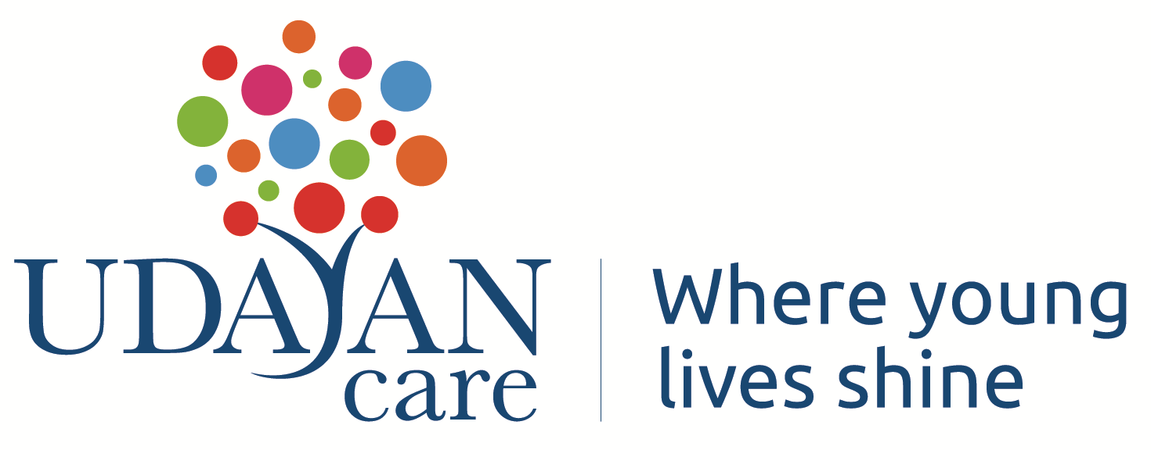
Position: Asst. Manager, Global Care Leavers Community
Location: New Delhi
Reports to: Asso. Director Advocacy

Section 1 | About Udayan Care
Udayan Care, an ISO 9000 certified organisation, has been working for the quality care of disadvantaged children and women and youth for over 24 years, with the endeavor of providing sustainable rehabilitation. The mission of “A nurturing home for every orphaned child; an opportunity for higher education for every girl and for every adult; the dignity of self-reliance and the desire to give back to society.” is what drives its 140 employees and close to 800 volunteers to action.
Based on the belief that a loving home & family is the right of every child, Udayan Ghars are long term residential homes that nurture children who are orphaned or abandoned in a family environment. Beyond 18, they get aftercare support and are educated and trained further, till job ready and independent. Udayan Care has been accredited by Give India, Guidestar & Credibility Alliance, for its transparent and credible performance. In 2015, the Honourable President of India awarded Udayan Care the National Award for Child Welfare 2014-India’s highest commendation for a non-profit child welfare organisation constituted by the Govt. of India

About the Project: Global Care Leavers Community
Udayan Care has always had a focus on ensuring the rights of youth in Alternative Care and towards this objective, it has undertaken several advocacy initiatives at national and international level. In 2020, along with other partners, a series of webinar was held with Care Leavers internationally between June and Sept 2020, and attended by over 100 Care Leavers from across the globe. This led to the Declaration of their demands titled “Responding to the transnational needs of Care Leavers amidst COVID-19” and has been endorsed by 42 organizations & networks. Taking this further, the “First International Care Leavers Convention 2020” was held virtually from November 23-25, 2020. The organizing partners were four Care Leavers Networks, namely Care Leavers Association and Network, India, Generation Never Give Up, Sri Lanka, Latin American Network of Care Leavers and Zimbabwe Care Leavers Network and four Civil Society Organisations, namely Kinderperspectief (Netherlands), SOS Children’s Villages, Udayan Care (India), University of Hildesheim (Germany). The Convention provided a unique platform and experience to Care Leavers globally to come together and voice their thoughts. Led by young care experienced persons from across the globe, the convention successfully met its objective to connect Care Leavers internationally and enable their coming together on a common safe platform to learn, share and exchange their experiences, knowledge and challenges, especially in the context of the pandemic. Around 2300 participants from over 83 countries from 6 continents attended this series of virtual meetings, webinars and engagement with transnational Care Leavers. The Care Leavers presented their demands before a panel of policy makers from 11 countries as a culmination of the Convention. Additionally, a resource website (www.careleaverscommunity.org) has been launched to further aid in the outreach and strengthening the network through the community page, discussion forum and periodic “Care Leavers Café” Sessions.

Section 2 | Purpose of the Role
The role holder is accountable for 360 degree management of the project called Global Care Leavers Community (GCLC) and managed by the A.R.T. department of Udayan Care. .
Section 3 | Key Responsibilities
- Efficient management of the Secretariat of the Global Care Leavers Community
- Coordination with all care leavers networks worldwide and ensuring their participation at the GCLC
- Managing the overall, Communication strategy, including social media and website with discussion forum including Quarterly newsletters, presentations and content development
- Working with global care leavers to ensure they become members of the community and contribute to its strengthening including Directory of care leavers network
- Co-ordinate with all partner organisations and all technical partners and other stakeholders, including policy makers, funding agencies and corporations, other NGOs, Consultants, etc. to ensure deliverables
- Effective development and implementation of the programs for the GCLC under guidance and supervision of the Working Steering Group of CLC, including monthly café sessions
- Ensure effective networking and collaborations with potential partners, funders, academia, CSOs
- Management of GCLC donors and funds, including donor reporting
- Ensure measuring outcomes of GCLC work, visibility and recognition through presence in right spaces and platforms
- Any other job or related task as advised by the Managing Trustee/ ED/ A.R.T. Director

Being a global project, work hours could be extended and weekend work shall be required always
Section 4 | Experience , Qualifications and Skills
Experience
Around 5+ years of work experience in national/international NGO with exposure to working with youth at transnational level is a must
Educational Qualifications
Masters or Bachelors in any recognized discipline or social sciences/law from an institute of repute.
Skills Requirements:
- Proven working experience and skills in project coordination, process planning and management
- Excellent verbal Communication skills, especially with international audience
- Excellent written communication skills, including report writing skills, social media posts etc.
- Good organizational skills including attention to detail and multitasking skills
- Strong working knowledge of Microsoft Office
- Developing and Tracking Budget

